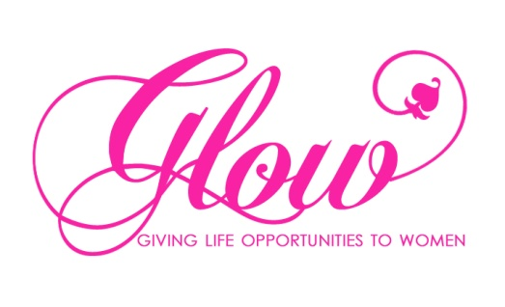

REGISTERED INTEREST FORM “Lily”

Referral Date:
Date Received:
(to be filled out by Glow)

Participant Details:
Young Person’s Name
Address
Age
Parent/Carer Name and Telephone Number
Email

Please return this form to: GLOW – info@glowni.com
Address: City Life Centre, 143 Northumberland Street, Belfast, BT13 2JF, 02890 239572

